
LESSON NOTE | DETAILED EXPLANATORY NOTES

GENETICS AND MOLECULAR BIOLOGY
GENES & CHRMOSOMES

GRADE 12- BIOLOGY

■ ■ ■

What are Genetics?
Genetics is the branch of biology that studies heredity and variation, explaining how characteristics are passed from parents to offspring and why individuals within a species are similar yet different. The fundamental units of heredity are genes, which contain the instructions that influence the traits and biological functions of living organisms.
Building on the study of DNA, genetics investigates how genetic information is organized into genes and chromosomes, how it is inherited across generations, and how variations arise within populations. Through genetics, scientists can explain the transmission of traits such as eye colour, blood type, disease susceptibility, and many other inherited characteristics.
Genetics is one of the most important fields in modern biology because it provides a foundation for understanding evolution, biodiversity, medicine, agriculture, biotechnology, and conservation. Knowledge of genetics enables scientists to study inherited disorders, improve crop and livestock production, develop medical treatments, and explore the genetic relationships among organisms.

The Branches of Modern Genetics
Modern genetics is organized into several interconnected branches, each focusing on different aspects of heredity and genetic information:
- Classical (Mendelian) Genetics – studies patterns of inheritance and how traits are passed from one generation to the next.
- Molecular Genetics – examines the structure, function, replication, and expression of DNA and genes at the molecular level.
- Cytogenetics – investigates chromosomes, their structure, behaviour, and role in heredity and genetic disorders.
- Population Genetics – studies genetic variation within populations and how genetic characteristics change over time.
- Genomics and Gene Manipulation – focuses on the analysis of entire genomes and the use of genetic technologies to study or modify genes.
Together, these branches help scientists understand how genetic information is stored, inherited, expressed, and altered, providing valuable insights into the diversity and continuity of life.

Genes & Chromosomes

Key Learning Outcomes
By the end of this lesson, students should be able to:
- Define and correctly use key genetic terminology, including gene, locus, allele, genome, chromosome, chromatid, centromere, telomere, homologous chromosomes, autosome, diploid, and haploid.
- Describe the levels of genetic organisation, from nucleotides and DNA sequences to genes, chromosomes, and the complete genome.
- Explain what a gene is and describe its role as the basic unit of heredity.
- Describe the structure of a gene, including its coding and regulatory regions, and explain how genes can be identified within a DNA sequence.
- Distinguish between prokaryotic and eukaryotic genes, including the presence of exons and introns in eukaryotic genes.
- Explain the process and significance of alternative splicing in generating protein diversity.
- Describe the structure of chromosomes and explain how DNA is packaged with histone proteins to form chromatin and chromosomes.
- Identify the major structural components of a chromosome, including chromatids, centromeres, telomeres, and chromosome arms.
- State the human chromosome number and distinguish between autosomes and sex chromosomes.
- Differentiate between diploid and haploid cells and explain their significance in sexual reproduction.
- Describe the purpose of a karyotype and explain how it is used to study chromosome number and structure.
- Identify common chromosomal mutations and explain how changes in chromosome structure or number can affect organisms.

What is a Gene?
A gene is the basic unit of heredity and consists of a specific sequence of nucleotides within a DNA molecule that contains the instructions for producing a biological product, usually a protein or a functional RNA molecule. Genes carry the information that determines many of the characteristics and functions of an organism.
Each gene occupies a specific position on a chromosome known as a locus. Genes are arranged one after another along the length of DNA molecules, with each gene containing information for a particular biological function. Different versions of the same gene, known as alleles, can result in variations in inherited traits.
Genes function by directing the synthesis of proteins, which perform essential roles in cells such as catalyzing chemical reactions, transporting substances, providing structural support, and regulating biological processes. Through gene expression, the information stored in DNA is ultimately translated into the characteristics observed in living organisms.
The complete collection of genetic material within an organism is known as its genome. The genome contains all of an organism’s genes as well as additional DNA sequences that help regulate gene activity and chromosome structure.

Levels of Genetic Organization
Genetic information is organized in a hierarchical manner:
Nucleotide → DNA → Gene → Chromosome → Genome
Each level builds upon the previous one, allowing large amounts of genetic information to be stored, organized, and transmitted efficiently within living organisms.
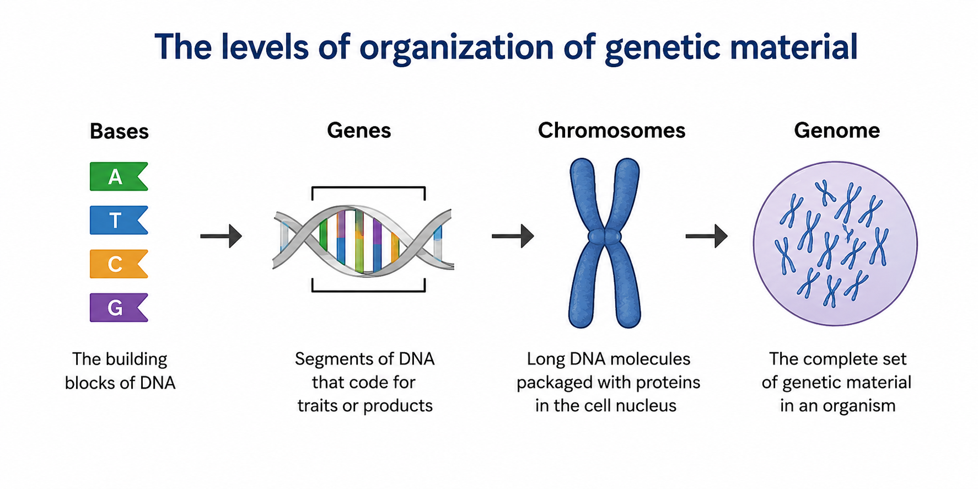

Figure 1: The levels of organization of genetic material — bases → genes → chromosomes → genome.

From Gene to Trait
Genes contain instructions for producing proteins, and these proteins contribute to the characteristics of living organisms. The relationship between genes, proteins, and traits can be summarized as:
Gene → Protein → Trait
For example, genes involved in melanin production influence skin, hair, and eye colour. Changes in a gene may alter the protein produced and affect the resulting trait.

Genes & Chromosomes – Terminologies and Concepts
The study of genetics involves several key terms that describe how genetic information is organized, stored, and inherited. Understanding these concepts is essential for interpreting how genes and chromosomes function within living organisms.
- Gene: A specific sequence of DNA that contains instructions for producing a protein or functional RNA molecule.
- Locus: The fixed position of a gene on a chromosome.
- Allele: One of the alternative forms of a gene that occupies the same locus on homologous chromosomes.
- Genome: The complete set of genetic material (DNA) present in an organism.
- Chromosome: A long DNA molecule packaged with proteins that contains many genes.
- Chromatid: One of the two identical copies of a replicated chromosome.
- Centromere: The constricted region that joins sister chromatids and serves as the attachment point for spindle fibres during cell division.
- Telomere: The protective DNA sequence located at the ends of chromosomes that helps maintain chromosome stability.
- Homologous Chromosomes: A matching pair of chromosomes that carry the same genes at corresponding loci, with one chromosome inherited from each parent.
- Diploid (2n): A cell containing two complete sets of chromosomes, one from each parent.
- Haploid (n): A cell containing a single set of chromosomes, such as sperm and egg cells.
These terms provide the foundation for understanding inheritance, chromosome behaviour, and genetic variation.

Why are Alleles Important?
Alleles are alternative versions of the same gene that occupy the same locus on homologous chromosomes. Different alleles can result in variations in traits, contributing to the diversity observed within populations. Individuals inherit one allele from each parent, creating unique genetic combinations that influence inherited characteristics.

The Structure of a Gene
A gene is more than just a coding sequence. It contains several regions that work together to control when, where, and how genetic information is expressed.
A typical protein-coding gene includes:
- Promoter: A regulatory DNA sequence that acts as a binding site for RNA polymerase and helps initiate transcription.
- Ribosome Binding Site: A region involved in the initiation of protein synthesis by helping ribosomes recognize the mRNA.
- Open Reading Frame (ORF): The coding sequence of the gene that contains the information needed to produce a protein.
- Transcription Terminator: A sequence that signals the end of transcription.
These components ensure that genes are expressed accurately and efficiently. The regulatory regions help control gene activity, while the coding region contains the instructions used to produce proteins that perform essential cellular functions.

Components of a Typical Gene
Gene Component | Function
Promoter | Initiates transcription
Ribosome Binding Site | Helps ribosomes recognise the transcript
Open Reading Frame (ORF) | Contains the protein-coding sequence
Transcription Terminator | Signals the end of transcription

Together, these elements enable genes to store information and regulate how that information is used within cells.
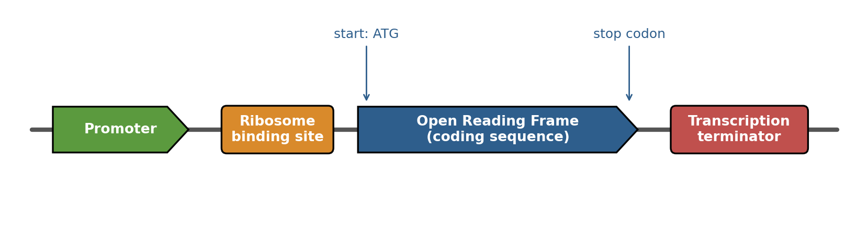

Figure 2: The basic structure of a protein-coding gene.

Locating a Gene in a DNA Sequence
Genes are identified within DNA by recognizing specific sequences that mark the beginning and end of a coding region. These signals help cells and scientists determine where a gene is located and which section of DNA contains the instructions for producing a protein.
Protein-coding sequences typically begin with a start codon, most commonly ATG in DNA. The start codon signals the beginning of the coding region and establishes the correct reading frame for protein synthesis.
Coding sequences end with one of three stop codons: TAA, TAG, or TGA. These codons do not code for amino acids but instead signal the end of the protein-coding sequence.
The continuous stretch of DNA between the start and stop codons is known as an Open Reading Frame (ORF). The ORF contains the genetic information that can be translated into a protein.
DNA contains two strands:
- Sense (Coding) Strand – has the same sequence as the mRNA transcript (except that DNA contains thymine while RNA contains uracil).
- Antisense (Template) Strand – serves as the template used by RNA polymerase during transcription.
Because nucleotides are read in groups of three, each DNA strand can be interpreted in three different reading frames. Since DNA has two strands, a total of six possible reading frames can be analyzed. Scientists and computer programs examine these reading frames to identify potential genes within DNA sequences.

Key Features Used to Locate Genes
Feature | Function
Start Codon (ATG) | Marks the beginning of a coding sequence
Open Reading Frame (ORF) | Contains the protein-coding region
Stop Codons (TAA, TAG, TGA) | Mark the end of a coding sequence
Sense Strand | Matches the mRNA sequence
Antisense Strand | Template for transcription

Identifying genes within DNA sequences is an important step in genetics, genomics, and bioinformatics, allowing scientists to determine where proteins are encoded within the genome.
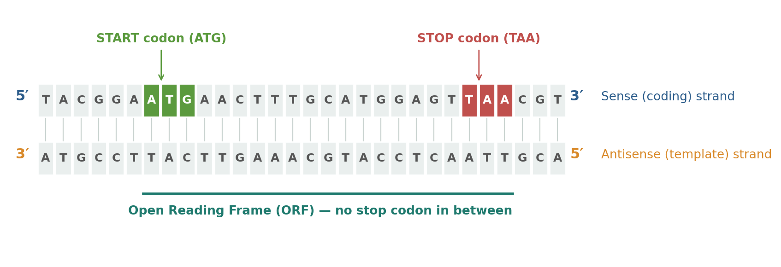
Figure 3:Locating a gene - start codon, stop codon and the open reading frame between them.

Genes in Prokaryotes and Eukaryotes
Although genes perform the same fundamental role in all living organisms, their structure differs between prokaryotes and eukaryotes.
In prokaryotes such as bacteria, genes are generally continuous sequences of DNA. The coding information is arranged in an uninterrupted manner, often described as "beads on a string." Because prokaryotic genes usually lack introns, the entire coding sequence can be transcribed and translated directly into proteins.
In eukaryotes, most genes are divided into exons and introns. Exons are the coding regions that contain the information used to produce proteins, while introns are non-coding regions that are removed before translation.
During gene expression, the entire gene is first transcribed into a preliminary RNA transcript. The introns are then removed through a process known as RNA splicing, leaving only the exons joined together to form mature messenger RNA (mRNA).
A particularly important feature of eukaryotic genes is alternative splicing. Through alternative splicing, exons can be combined in different ways, allowing a single gene to produce multiple protein products. This greatly increases protein diversity without requiring a large increase in gene number.
Alternative splicing helps explain how humans can produce hundreds of thousands of different proteins despite having only about 20,000–25,000 genes.

Comparison of Prokaryotic and Eukaryotic Genes

Feature | Prokaryotic Genes | Eukaryotic Genes
Arrangement | Continuous coding sequence | Split into exons and introns
Introns | Usually, absent | Usually, present
RNA Processing | Minimal | Extensive splicing required
Alternative Splicing | Rare | Common
Protein Products | Usually, one gene → one protein | One gene may produce multiple proteins

Why is Alternative Splicing Important?
Alternative splicing increases genetic efficiency by allowing a single gene to produce different protein variants. This contributes to the complexity of higher organisms and enables cells to produce proteins that are specialized for different functions and tissues.
As a result, alternative splicing plays an important role in growth, development, adaptation, and cellular diversity.
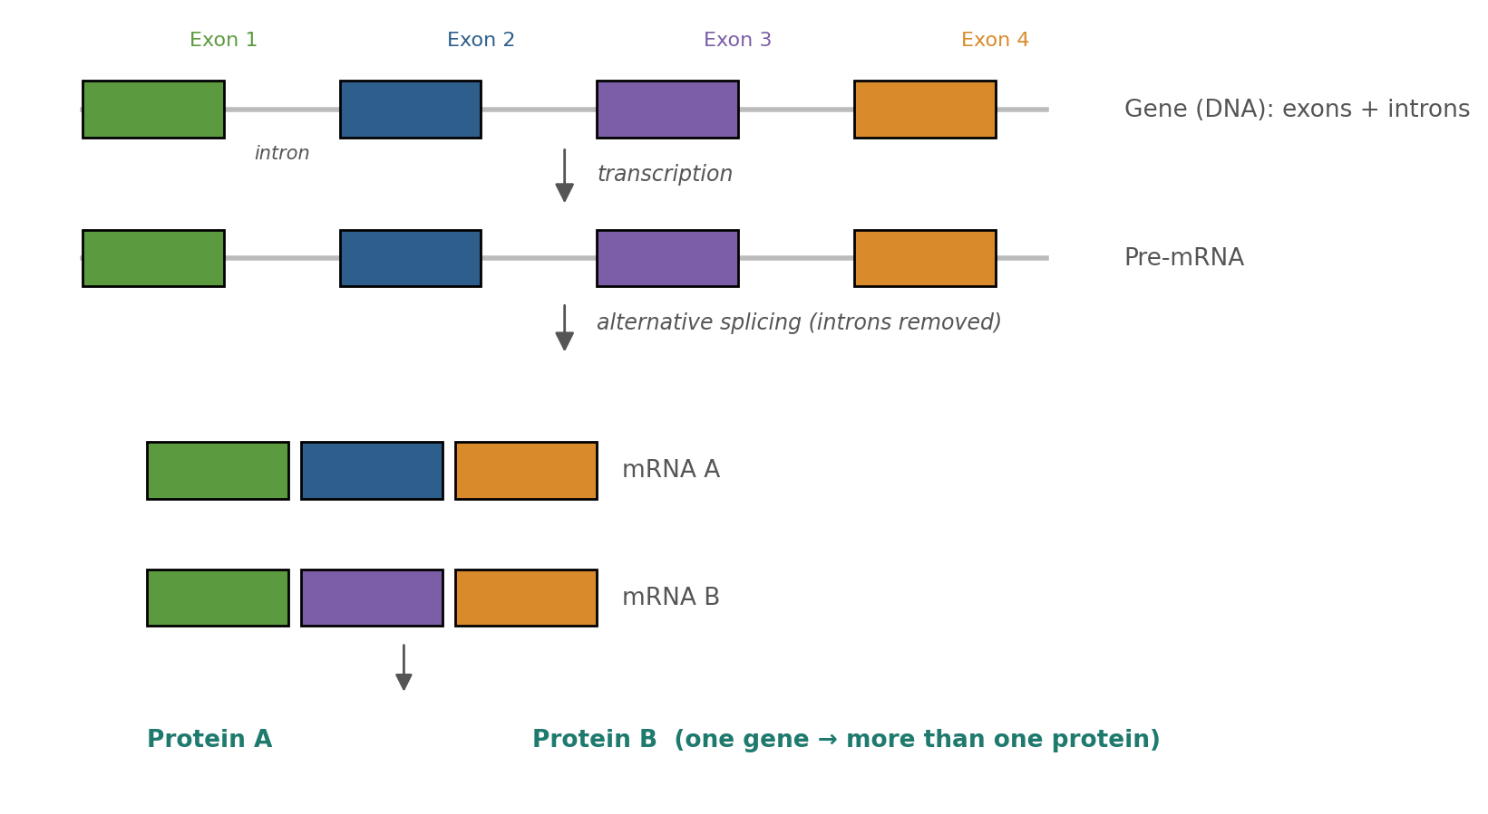

Figure 4: Eukaryotic genes are split into exons and introns; alternative splicing lets one gene make several proteins.

What is a Chromosome?
A chromosome is a thread-like structure composed of DNA and proteins that carries genetic information in the form of genes. Chromosomes serve as the organized packages of DNA within cells, ensuring that genetic information can be stored, protected, and accurately transmitted during cell division.
Each chromosome contains a single, long DNA molecule associated with proteins called histones. Depending on the organism, a chromosome may contain thousands of genes and millions of base pairs. In humans, some chromosomes contain up to hundreds of millions of DNA base pairs.
One of the remarkable features of chromosomes is their ability to compact large amounts of DNA into a very small space. If the DNA from a single human cell were stretched out completely, it would measure approximately two meters in length. Through a series of packaging steps, this DNA is condensed sufficiently to fit within a nucleus only a few micrometers in diameter.
DNA is first wrapped around histone proteins to form nucleosomes, often described as "beads on a string." These nucleosomes coil and fold further to form chromatin, which becomes highly condensed during cell division to produce visible chromosomes.

DNA Packaging Pathway
DNA → Nucleosome → Chromatin → Chromosome
This packaging system protects DNA, maintains organization, and ensures the accurate distribution of genetic material during cell division.

The Anatomy of a Chromosome
A duplicated chromosome consists of two identical sister chromatids joined together at a region called the centromere. These chromatids are produced during DNA replication and contain identical genetic information.
Several important structures can be identified within a chromosome:
- Sister Chromatids – two identical copies of a replicated chromosome.
- Centromere – the constricted region that joins the sister chromatids and serves as an attachment point for spindle fibers during cell division.
- Telomeres – protective DNA sequences located at the ends of chromosomes that help maintain chromosome stability.
- Short Arm (p arm) – the shorter section of the chromosome extending from the centromere.
- Long Arm (q arm) – the longer section of the chromosome extending from the centromere.
These structural features help chromosomes maintain their integrity and ensure the accurate movement of genetic material during cell division.

Main Parts of a Chromosome

Structure | Function
Sister Chromatids | Identical copies containing the same genetic information
Centromere | Holds chromatids together and attaches spindle fibers
Telomeres | Protect chromosome ends from damage
p Arm | Short arm of the chromosome
q Arm | Long arm of the chromosome

The structure of chromosomes enables cells to store, protect, and distribute genetic information efficiently, making chromosomes essential for heredity, growth, and reproduction.

The Importance of Telomeres
Telomeres are protective DNA sequences located at the ends of chromosomes. They prevent chromosome ends from deteriorating, losing important genetic information, or fusing with neighbouring chromosomes. Telomeres help maintain chromosome stability and play an important role in protecting genetic material during cell division.
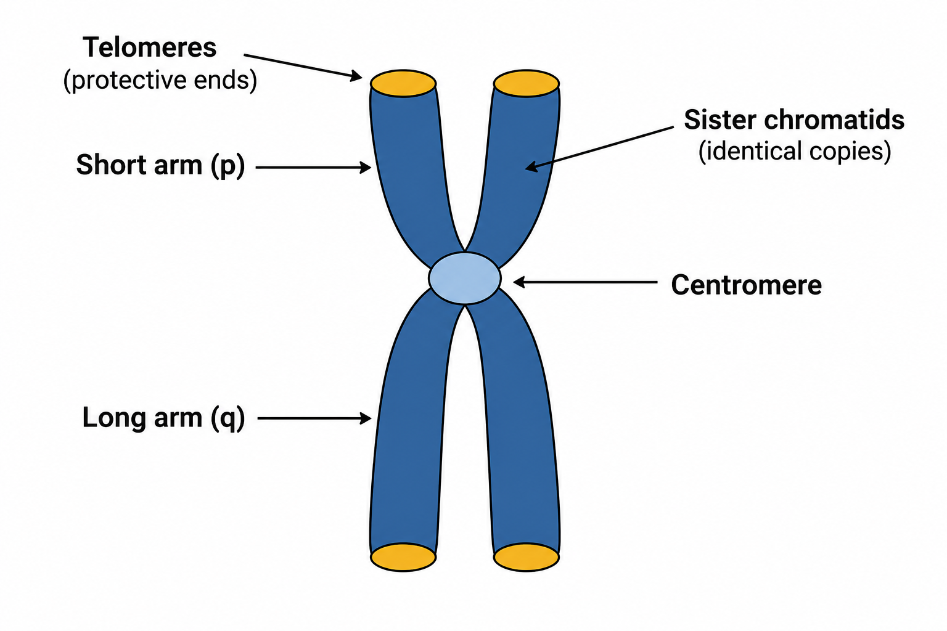
Figure 5: The anatomy of a duplicated chromosome.

Chromosome Number: Diploid and Haploid
Humans possess 46 chromosomes arranged in 23 homologous pairs, with one chromosome of each pair inherited from the mother and the other inherited from the father. These chromosomes contain the genetic information required for the growth, development, and functioning of the human body.
Of the 23 chromosome pairs:
- 22 pairs are autosomes, which carry genes responsible for most body characteristics and functions.
- 1 pair consists of sex chromosomes, which determine biological sex. Females typically have XX chromosomes, while males typically have XY chromosomes.
The complete set of chromosomes within a cell can be displayed and analyzed using a karyotype, an organized arrangement of chromosomes according to size, shape, and centromere position. Karyotypes are commonly used to identify chromosomal abnormalities and genetic disorders.
Body cells contain two complete sets of chromosomes and are therefore described as diploid (2n). In humans, the diploid chromosome number is 46 (2n = 46).
In contrast, reproductive cells (gametes), such as sperm and egg cells, contain only one set of chromosomes and are described as haploid (n). Human gametes contain 23 chromosomes (n = 23) and are produced through the process of meiosis.
During fertilization, a haploid sperm cell combines with a haploid egg cell to form a diploid zygote, restoring the normal chromosome number:
23 (sperm) + 23 (egg) = 46 (zygote)
This process ensures that chromosome numbers remain constant from one generation to the next while allowing genetic information to be inherited from both parents.

Diploid and Haploid Cells

Feature | Diploid Cells (2n) | Haploid Cells (n)
Number of Chromosome Sets | Two sets | One set
Human Chromosome Number | 46 | 23
Found In | Body cells | Gametes (sperm and egg)
Produced By | Mitosis | Meiosis
Function | Growth, repair and maintenance | Reproduction

The Importance of Diploid and Haploid Numbers
Maintaining the correct chromosome number is essential for normal growth, development, and reproduction. The alternation between diploid and haploid stages ensures that offspring inherit genetic material from both parents while preventing chromosome numbers from doubling in each generation.
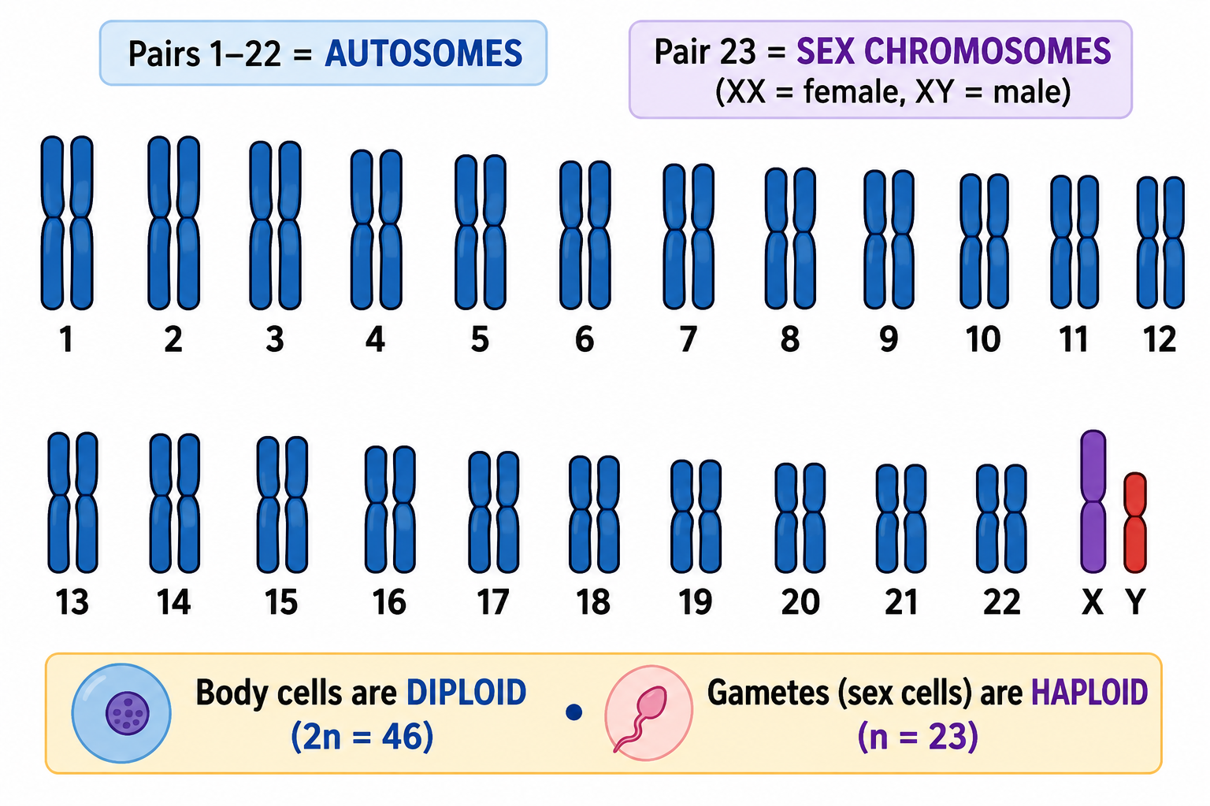
Figure 6: A human karyotype - 46 chromosomes as 23 pairs (22 autosome pairs + sex chromosomes).

Chromosomal Mutations
Chromosomal mutations occur when the structure or number of chromosomes changes. These changes can arise naturally through errors during cell division or as a result of environmental factors such as radiation, certain chemicals, or viral infections. Chromosomal mutations can introduce genetic variation within populations, but they may also disrupt normal gene function and lead to developmental abnormalities or genetic disorders.
Chromosomal mutations are generally classified into two main categories:

Structural Chromosomal Mutations
Structural mutations involve changes to the physical structure of a chromosome.
- Deletion – A segment of a chromosome is lost, resulting in the loss of genetic information.
- Duplication – A segment of a chromosome is copied and repeated, leading to extra genetic material.
- Inversion – A chromosome segment breaks off, rotates, and reinserts in the opposite orientation.
- Translocation – A chromosome segment breaks away and attaches to a different chromosome.
These structural changes can alter gene arrangement and may affect gene expression or chromosome function.

Numerical Chromosomal Mutations
Numerical mutations involve changes in chromosome number and usually occur due to non-disjunction, a failure of chromosomes to separate properly during meiosis.
As a result, some gametes may receive too many or too few chromosomes. If such gametes participate in fertilization, the resulting offspring may possess an abnormal chromosome number.
One well-known example is Trisomy 21 (Down Syndrome), in which an individual has three copies of chromosome 21 instead of the usual two.

Types of Structural Chromosomal Mutations

Mutation Type | Description
Deletion | Loss of a chromosome segment
Duplication | Repetition of a chromosome segment
Inversion | Reversal of a chromosome segment
Translocation | Movement of a chromosome segment to another chromosome

Importance of Chromosomal Mutations
Chromosomal mutations contribute to genetic variation, which is important for evolution and adaptation. However, significant changes in chromosome structure or number can interfere with normal development and may result in genetic disorders, reduced fertility, or other health conditions.
Understanding chromosomal mutations helps scientists diagnose genetic disorders, study inheritance patterns, and investigate the causes of chromosomal abnormalities.

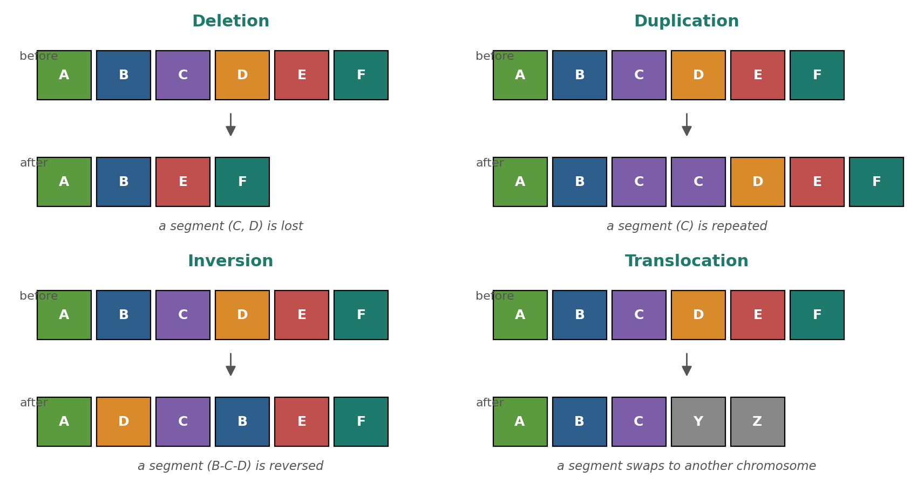

Figure 7: The four main types of structural chromosomal mutation.

Worked Example – Diploid to Haploid
Human body cells contain 46 chromosomes arranged in 23 homologous pairs and are therefore described as diploid (2n = 46). During the process of meiosis, these homologous chromosome pairs separate so that each reproductive cell (gamete) receives only one chromosome from each pair.
As a result, sperm and egg cells contain 23 chromosomes and are described as haploid (n = 23).
The process can be summarized as follows:
Diploid Body Cell (46 chromosomes)
↓ Meiosis
Gametes (23 chromosomes each)
↓ Fertilization
Zygote (46 chromosomes)
Therefore:
23 (sperm) + 23 (egg) = 46 (zygote)
This restoration of the diploid chromosome number ensures that chromosome numbers remain constant across generations. It also explains why offspring inherit half of their chromosomes from their mother and half from their father.

Why Genes & Chromosomes Matter
Genes and chromosomes are fundamental to life because they store, organize, and transmit the genetic information that controls the characteristics and biological functions of organisms.
- Heredity – Genes located on chromosomes are passed from parents to offspring. Through meiosis and fertilization, genetic information is transmitted between generations, explaining family resemblance and genetic variation.
- The Body Plan – Genes contain the instructions for producing proteins that control growth, development, metabolism, and cellular activities. Through the central dogma, genetic information is used to build and maintain the entire organism.
- Genetic Variation – Differences in genes and chromosomes contribute to the diversity observed within populations and provide the raw material for evolution.
- Medicine and Biotechnology – Understanding genes and chromosomes allows scientists and healthcare professionals to diagnose genetic disorders, analyze inherited conditions, develop medical treatments, and apply biotechnology to agriculture, medicine, and research.
- Modern Biological Research – Genetics forms the foundation of fields such as genomics, bioinformatics, genetic engineering, personalized medicine, and conservation biology.
By understanding genes and chromosomes, students gain insight into how genetic information is organized, inherited, and used to control the structure and function of living organisms.

PNG Context Example
Knowledge of genes and chromosomes has practical applications in Papua New Guinea. Scientists use genetic information to study biodiversity, improve crop varieties, investigate inherited traits, and support conservation efforts. Understanding genetic variation can contribute to sustainable agriculture, food security, and the management of biological resources.

References & Related Documents

Source Documents
- STEM Biology Student Resource Book - Grade 12, Term 1. Module 12.1 Bioinformatics, Topic 1 (Activities 2 & 3: Genes; Chromosomes). Department of Education, PNG (2021).
- Biology Standards-Based Syllabus, Grades 11 & 12 (PNG SBC 2020) - Strand 2: Life, Unit 2 Genetics; Benchmarks 12.2.2.2 and 12.2.2.3.

Further Reading & References
- Alberts, B., et al. (2002). Molecular Biology of the Cell (4th Ed). Garland Science, New York.
- OpenStax Biology - https://openstax.org/books/biology
- National Human Genome Research Institute - https://www.genome.gov

